Recoil

Cordeiro Dominic Gabriel Tan 1002811

Lee Gui An 1002651

Low Wei Leong Lucus 1002767

Marooth Nath Chaowanasatier 1002923

Soh Jun De 1002682

Tey Siew Wen 1002827

Table of Contents

**Overview** **4**

Abstract / Vision Statement 4

Target Platform 4

**Background Study** **5**

Similar Games 5

Super Meat Boy 5

Celeste 5

VVVVV 6

Conclusion 7

**Gameplay** **8**

Objectives 8

Target Audience 8

Core Drive 9

Development and Achievement 9

Social Influence and Relatedness 10

Epic Meaning and Calling 10

Game Progression 10

**Formal Elements** **11**

Game Procedures and Mechanics 11

Movement 11

Weapon 11

Stage 13

Pickups 14

Terrain 16

Player Mode 16

Game Rules 16

Operational Rules 16

Constitutive Rules 17

Resources 17

Conflict 17

Level Design 17

Game Balance 18

Boundaries 18

Resolution 18

**User Testing** **19**

Alpha Testing 19

Beta Testing 1 (Pre-checkpoint 3) 19

Beta Testing 2 (Pre-checkpoint 3) 19

Release Candidate Testing 3 (Pre-checkpoint 4) 20

**Assets** **21**

**Schedule** **22**

**Appendix** **24**

Appendix A - Assets 24

Main Characters 24

Enemies 26

Player Weapons 28

Pickups 29

Background 30

Appendix B - Level Design Sketches 31

# 

# Overview

The following document describes Aghs Carry Dazzle’s game design master document for Recoil, a platformer adventure game playable on PC computers.

## Abstract / Vision Statement

*Recoil* is an adventure platformer game wherein a player assumes the role of Pingu the Penguin and guides them through a secret lab in an attempt to find and recover their baby cousin Benedict the Egg, which has been stolen by the NAVY SEAL. All actions take place on a two-dimensional map segmented into ‘rooms’ and the entire game operates in real-time. Using a mouse and keyboard, the player will move the character from room to room, progressing across multiple platforming challenges and occasionally engaging in combat. The character faces challenges in the form of both hostile monsters and traps in their quest to ascend further into the secret lab, both of which provide impediments to further progress, and are lethal to the character.

The character will find additional different methods for traversing vertical and horizontal space at fixed points in the game world as they delve further into the secret lab, and acquire new equipment that changes the way that they interact with the game environment. Checkpoints are set at the start of various rooms to allow for the player to minimize the penalty of a mistake and emphasize the skill growth of the player.

The heart of *Recoil* is the recoil-based jump. In order for the player character to jump, they must fire their weapon, which only reloads itself when the player collects a power-up or lands on the ground once again. This is the only means by which a player will have the ability to bridge gaps in each room that they arrive at. In addition to platforms, the character will need to pass through several rooms in which a correct sequence of events need to be achieved in order to reach the end of the room. The character’s quest ends with the defeat of the NAVY SEAL, located deep in the secret lab.

Expandability is also key to *Recoil*’s success. The variety offered by the recoil jump mechanics and combined platform challenge mechanics offers avenues of expansion for further development, should additional development time become available.

## Target Platform

*Recoil* is targeted at desktop platforms (Windows). MacOS was originally considered, but given the lack of build tools for the MacOS platform, it was abandoned, as none of the team members uses a MacBook or iMac, which are required to successfully build for MacOS.

# 

# Background Study

## Similar Games

### Super Meat Boy

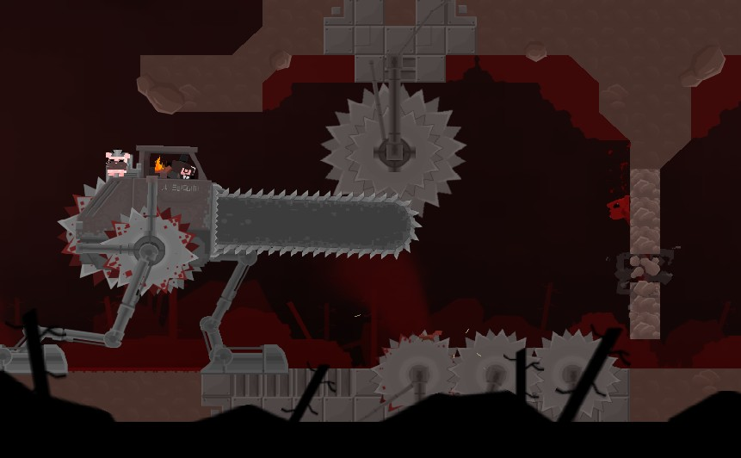

Fig 1. Super Meat Boy

Super Meat Boy, developed by Team Meat in 2010, is a 2D platformer game that is well-known for its precise controls and tight level design. It is beloved by players as a prime example of a game that tests the measurement abilities of its players, asking them to navigate a maze of dangerous traps through well-timed and precise climbing and jumping. For *Recoil*, we borrow heavily from this “simple to learn but difficult to master” design philosophy to develop our levels - and in doing so aim to do more with less, combining two common platformer game verbs (attacking and jumping) into a singular form and building our challenges around the mastery of this core mechanic.

### Celeste

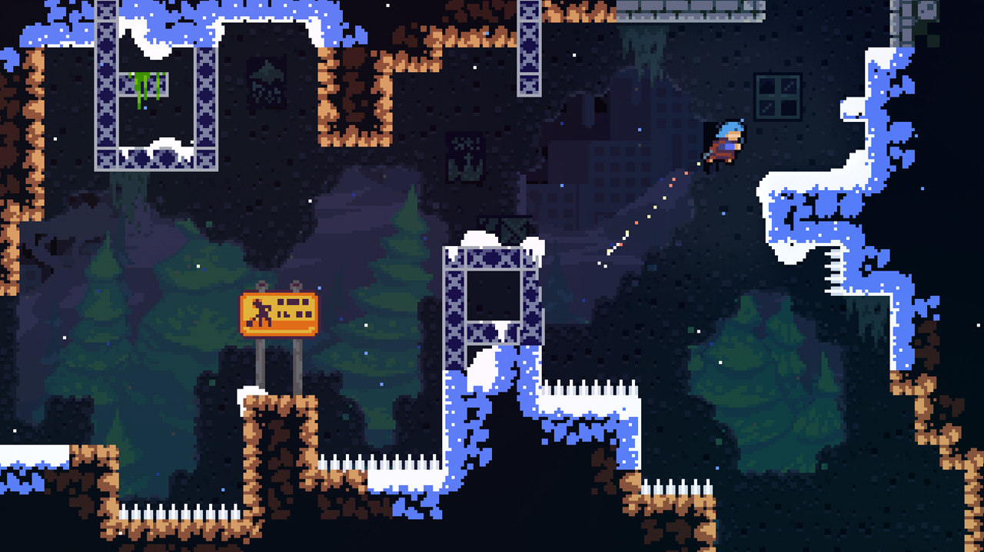

Fig 2. Celeste

Celeste is an all rounded 2D platformer game that is praised for its level design and fine tuned controls.

Celeste’s level design enhances the experience of figuring out each puzzle by providing a safe environment for the player to fail by having close and quick respawns. This makes the game very accommodating to players across a wide range of skill levels, and it is something that we would include in our game design.

Celeste has very intuitive movement controls - walk, jump, dash and climb. These controls are relatable to real life movement and are easy to pick up for beginners. However, the controls are much more fine tuned than other platformers as players are able to make precise jumps based on how long they press the jump button. This leads to a learning curve for players to calibrate themselves to the game controls. Without sufficient mastery, they will not be able to avoid traps and navigate through the stages. Furthermore, by limiting the number of jumps/speed boosts the player can have without touching the floor (and only refilling them in midair using certain pickups), each stage is further developed such that no movements should be wasted, adding to the skill required to play this game. Celeste thus imparts the importance of having simple mechanics for the player to pick up yet requiring mastery for game progression to feel rewarding. Hence, for our game, we added a fun twist on this concept by removing the default jump and enabling only vertical movement with the use of simple recoil mechanics from the player’s weapons which are limited in ammo charges.

There are also optional tokens in Celeste that players could collect if they choose to go the extra mile to solve additional puzzles. Although attaining these tokens do not necessarily improve the ease of reaching the main game objective, and in fact does consume a significant amount of the player’s time, these tokens help players to feel a greater sense of accomplishment that they are playing well. Hence, we have incorporated this idea in the form of ‘easter eggs’ that are strategically placed in *Recoil*’s game stages that rewards players with additional lore, if they are able to reach them.

### VVVVV

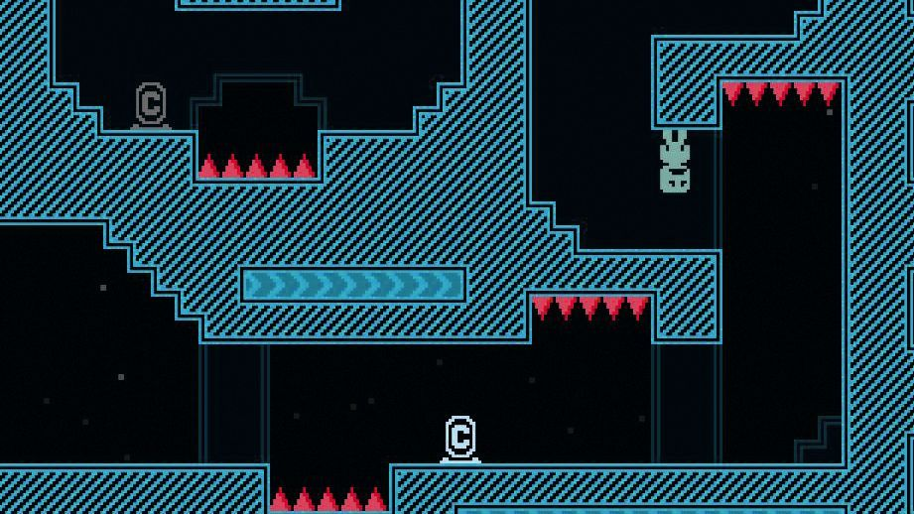

Fig 3. VVVVV

VVVVV is a 2D platformer developed by Terry Cavanagh lauded for its highly experimental take on the platforming genre. It took away the capacity for jumping, instead giving players the power to invert the direction that gravity acts on, creating a fascinating system where players had to be strategic with their swaps in order to successfully traverse the platforming challenges. Similarly, for *Recoil*, we seek to expand what is possible in the navigation of the 2D space, and VVVVV provides an excellent case study both in the form of questioning convention and also in removing a verb that is almost typical of the platformer experience - jumping.

## Conclusion

Based on the games reviewed above, our game seeks to further explore ways where the player can maneuver himself through the platforms through a combination of guns that vary the ways the player may travel. This is built atop existing games by making air control a scarce resource, as well as providing knockbacks that do not come immediately (in the form of the rocket launcher) which encourages the player to prepare and time these knockbacks in combination with other existing guns.

# Gameplay

## Objectives

The objective of the game is to complete levels by using a variety of different weapons. Players complete levels by navigating the stage while being impeded by various obstacles that they must use the guns to overcome. The overall narrative of the story is that players head further into the lab to eventually find and defeat the Navy Seal.

## Target Audience

*Recoil* is designed to primarily appeal to two kinds of players, referred to in the Octalysis framework as the *Killer* and *Explorer* archetype. It is catered to players of all skill levels, and game progress is primarily gated behind mastery of the recoil mechanics of different weapons.

1. For the competitive *Killer* players, there is the presence of plentiful obstacles in the form of enemies and traps, along with the presence of the competitive scoring system which gives players metrics for competition in the form of a proxy mistake counter in the death counter mechanic.
2. For *Explorers* who seek out the thrill of discovery, *Recoil* includes bonus easter eggs which require players to venture off the beaten and obvious track, and achieve mastery over the strategic use of their weapons in order to find.

## 

## Core Drive

Yukai-Chou’s Octalysis Framework is a popular tool for understanding how different aspects of a game design would make it a fun and enjoyable experience for players. As such, we applied it to analyze our current game design as shown in Fig 4.



Fig 4. Octalysis of *Recoil*

### Development and Achievement

*Recoil* is designed to reward players who achieve mastery over the core game mechanic of gun recoil movement with progression. As further progress in the game is gated by mastery of the skills needed to traverse the game stage, each stage’s completion is in turn designed to give a sense of achievement as defeat obstacles in their way. *Recoil*’s stages are also specially designed with an open-ended solution space, with no single optimal path in mind, and a tight gameplay loop which allows players to respawn quickly if they do make a mistake. This helps to both fight player frustration and to make players feel like achievement is possible.

Additionally, the completion of a number of stages gives players access to a new weapon that adds new mechanics and variety to their playing style, which in turn creates a feedback loop of mastery that lets players continually experience the rush of achievement as they rapidly master each new mechanic as it is introduced. This also provides great incentive for players to complete stages with great ease of replayability.

### Social Influence and Relatedness

Even in a single-player platformer game, *Recoil* offers a competitive sphere by allowing players to gauge each other’s skills and offering them bragging rights in the form of benchmarks for the time taken to finish the game. As such, we propose leaderboard features in the form of a timer that will allow a user to track their elapsed gameplay time that can be used for comparison to others after they complete the game. By giving players the option to be competitive, this also enhances their game play experience and the replayability of the game as they attempt speed runs. Dying less and being able to utilize recoil mechanics more effectively will aid them to climb the leaderboard higher. For players that choose not to participate, they will also be able to enjoy the story as it appeals to the core drive of Epic Meaning and Calling.

### Epic Meaning and Calling

The premise of the game is based on heroism. In this game’s story, the player is a humane protagonist that tries his best to overcome hurdles to rescue and retrieve back his lost item, which is stolen by the antagonist. The game will also have a narrative that puts a more humorous tone to this relationship. This will help players to feel more emotionally invested to look forward to what is next in the story and gameplay.

## Game Progression

*Recoil* as a project is estimated to last about 15-20 minutes of serious playtime, including learning how to play the game. The player is expected to proceed through 4 stages in total, with each stage subdivided into smaller rooms that form the basic unit of challenge for *Recoil*.

The tutorial stage is planned to have 5 rooms in total to teach the very basics of the game, such as movement, the gun recoil mechanic, and bridging small vertical and horizontal distances.

Further stages will also have about 5 rooms each and we plan to introduce new weapons at about the mid-stage point (approximately 2 rooms in). This gives players both the time necessary to get comfortable with a stage’s theme and design, as well as the necessary space and play area for them to familiarize themselves with the changed mechanics of the new weapon, which will switch up their play style.

This is topped off with a “boss stage”, in which players will be expected to execute on the techniques and the skills that were taught to them throughout the stages with time pressure in order for them to complete the game. This also serves as the final test for players to demonstrate their mastery over the game.

# 

# Formal Elements

## Game Procedures and Mechanics

### Movement

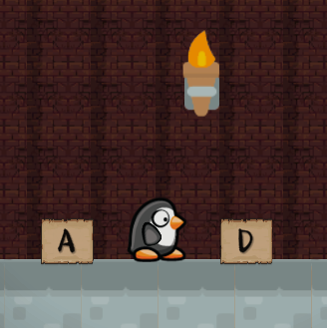

Fig 5. Horizontal Movement Controls

Players are able to move with the standard keyboard shortcuts of A and D for horizontal movement. With the use of guns, vertical movement can be achieved as well as greater horizontal distance. Players have limited horizontal air control while in the air. Unlike traditional 2D platformer games where the “Space” key is used for jumping, vertical movement can only be achieved by shooting in a generally downward direction, using the recoil of each weapon to propel the player in the opposite direction. This is demonstrated in Fig. 6.

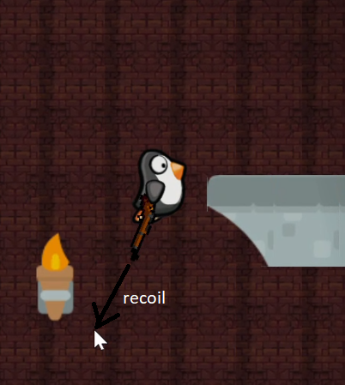

Fig 6. Arrow dictating the recoil force that is pushing Pingu forward in the opposite direction

### Weapon

Players have to use the various guns they find throughout the game and use the recoil from firing these guns in order to move vertically or get more horizontal movement. We propose 3 types of weapons, one of which is unlocked in the middle of the tutorial stage. The other two will be unlocked subsequently in later stages.

Weapons have limited magazine sizes and reload on contact with the ground. Hence, players are unable to fire indefinitely and must reload their weapons either by touching platforms or pass a ‘firing’ cooldown in order to fire again. Each weapon will have initial limited charges of ammo that can be replenished with their respective recharge time. The purpose of the individual weapons also differs. The first weapon is a Shotgun, the second weapon is the Rocket Launcher, and the last weapon is a Flamethrower.

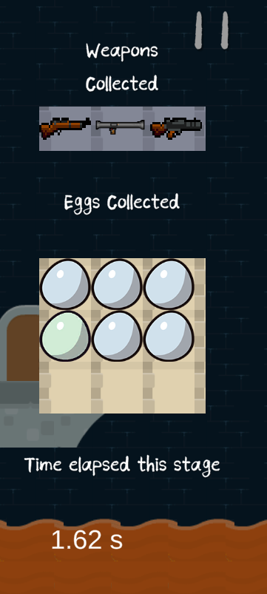

Fig 7. Weapons available: Shotgun, Rocket Launcher, Flamethrower (from left to right)

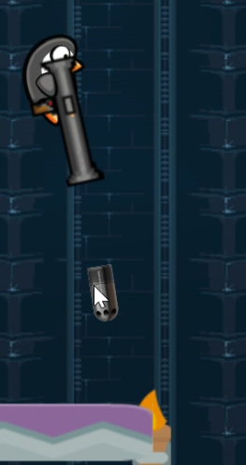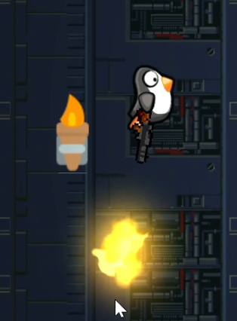

Fig 8. Weapons that release projectile(s) when shot: Shotgun, Rocket Launcher, Flamethrower (from left to right)

1. The Shotgun comes with 2 shots. It is the first gun that the player uses and fires 3 projectiles in a cone shaped pattern from the muzzle of the gun. The shotgun delivers its recoil when fired, and is the first weapon that players will get access to.
2. The Rocket Launcher comes with 1 shot. It fires a slow moving projectile that creates a recoil when it collides with a platform/enemy. This projectile can be used to create recoil that is originally inaccessible to players where they need it, requiring them to plan and fire the launcher ahead of time.
3. The Flamethrower comes with 10 shots. It serves to aid players in air control while being in the air, giving them the maneuverability in air to complete specific stages. The flamethrower delivers a controllable stream of recoil which can be used to maneuver around difficult terrain.

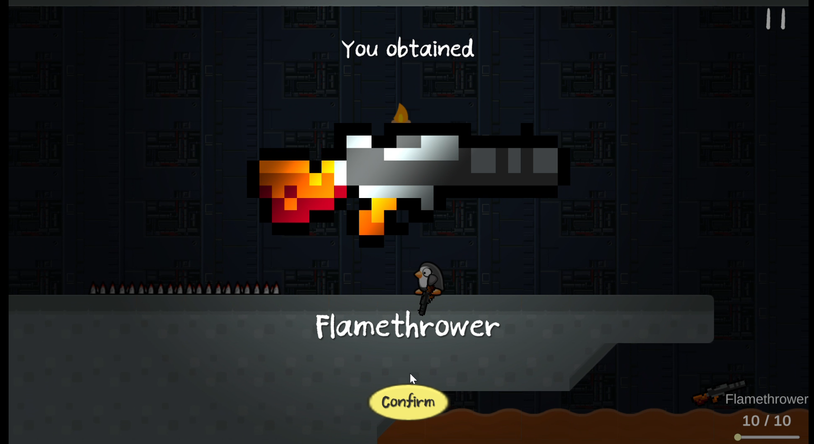

Fig 9. Weapon Pickup UI

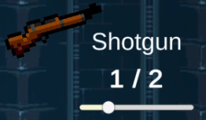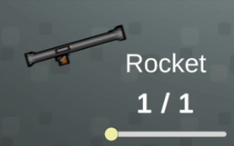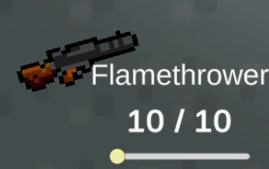

Fig 10. Weapon UI to show currently equipped gun, ammo left and reloading state

Upon picking up the weapon from the weapon crates (under the Pickups section), players will see a confirmation interface with a shiny effect on the weapon to make the process of obtaining weapons feel more special (Fig. 9) and give them a greater sense of accomplishment for coming thus far. Players will also see the Weapon UI which displays their currently equipped weapon, ammo left in the gun and the max ammo that each weapon possesses (Fig. 10). The slider in the Weapon UI will start to move towards the right if the player is on the ground and on reload cooldown.

### Stage

Different stages have their own challenges. Each room is marked by the presence of a platforming challenge, which requires that players execute and navigate them in specifically-designed ways. This is also used to teach players important core skills that will be valuable in making it through future rooms and clearing the boss stage. Ultimately, players advance within stages by finding and reaching the exit door within a stage, typically demarcated by a closed door (Fig 11). To guide users towards the exit door of each stage, cosmetic items such as lights and signposts are placed. They are however free to navigate the space of the stage however they wish, as outlined in the basic game rules.

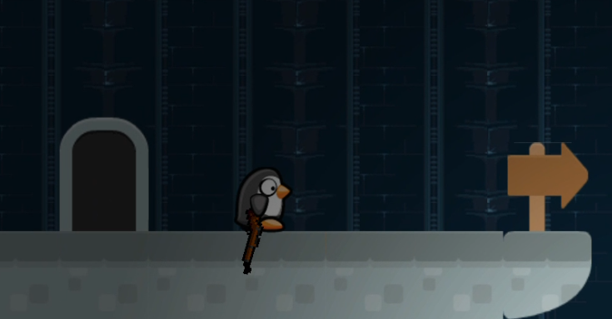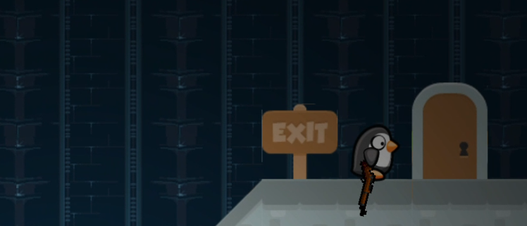

Fig 11. Entry Door (left), Exit Door (right)

Players will instantly die if they get hit by enemies or touch dangerous objects like spikes (Fig. 12). If the player dies, they are able to respawn quickly at the entry door of the stage (Fig. 11) and get back to the game. Players have unlimited lives, although the number of times they have spawned do get recorded at the game results.

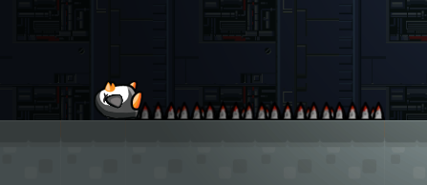

Fig 12. Pingu dying of spikes

In addition to the dangerous elements, some stages also come with Pickups, which are summarized in the next section.

### Pickups

There are 4 main pickups in the game, as shown in Table 1 below, each comes with their own description and purpose.

|  |  |  |  |
| --- | --- | --- | --- |
| **Name** | **Sprite** | **Description** | **Purpose** |
| Weapon Crate |  | A leftover crate containing a weapon. | For players to **get a weapon**. For example, the crate in TutorialStage2 will yield them the Shotgun while in Stage 3-1, this will yield them the Flamethrower. |
| Energy Core |  | A core filled with energy and becomes fuel for Pingu’s weapons upon contact. | Instantly **reloads Pingu’s weapons, even while midair**. Necessary to be picked up for clearing certain stages that test the player’s precision and air control skill to overcome large distances. |
| Collectible Egg |  | Some birdy else’s chick, shaking.  There are a total of 9 eggs to be found in the entire game, excluding Benedict, that can be found in RGB colors. | Bonus item for users who go out in search of it - **does not aid in gameplay but gives satisfaction for collectors and shaping the narrative**. Sometimes it also provides tips about upcoming stages. |
| Hint |  | The remains of a blueprint that dictate how certain rooms of the Navy Seal’s labyrinth work. | Shows a user interface that provides players with **tips to clear a stage.** |

Table 1. Pickups

Pickups are introduced early in the Tutorial Level, where players receive their first weapon, the Shotgun, and also encounter the Hint Pickup which will bring up a UI to introduce players to non-passable platforms and floating platforms (Fig 13).

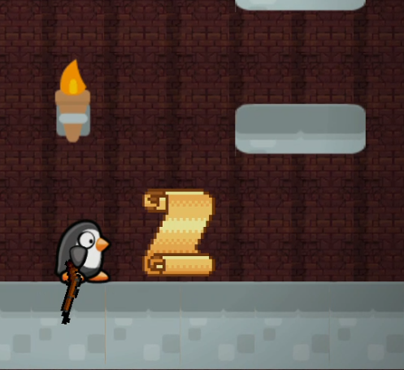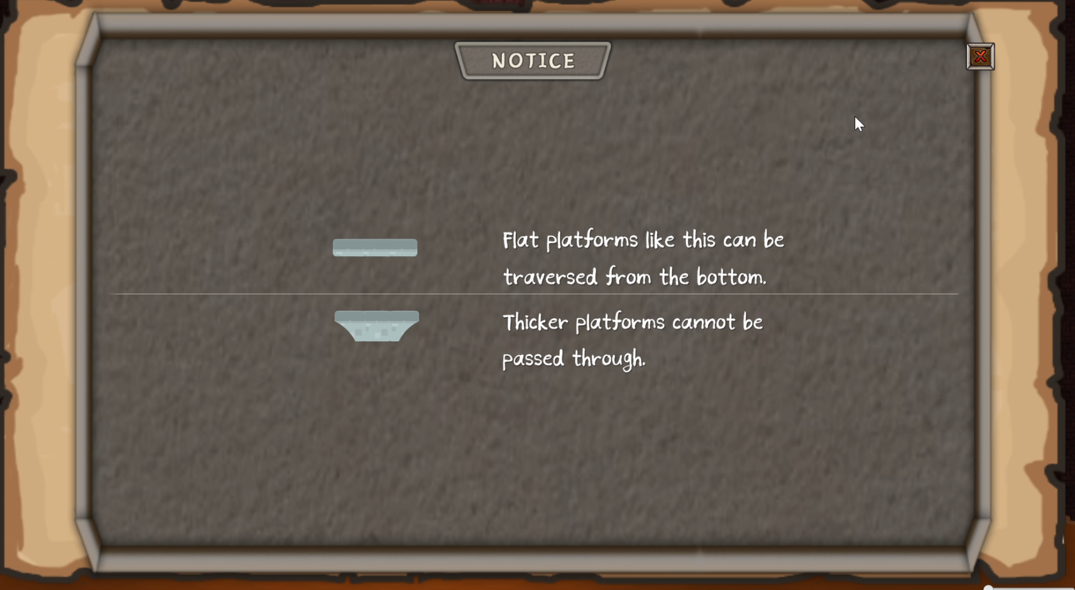

Fig 13. Tutorial Stage 3: Introduction of Hint Pickup

The first Egg that they pick up will also inform users of the existence of the inventory in their Pause Menu (Fig. 14). The Egg Pickup will also have a visual cue of vibrating and occasional audio cue of penguin baby chirps if the player is close enough to the egg. This helps players to realize that there is an Collectible Egg nearby in case they missed it due to the camera’s angle.

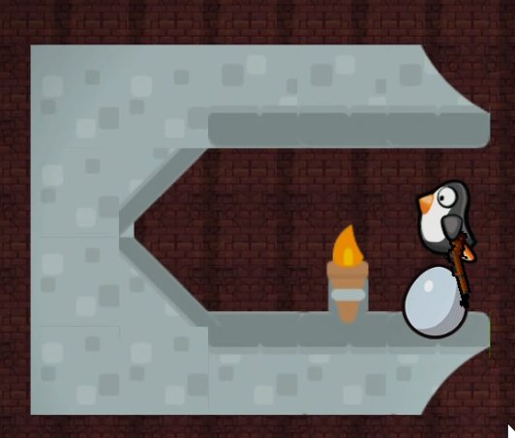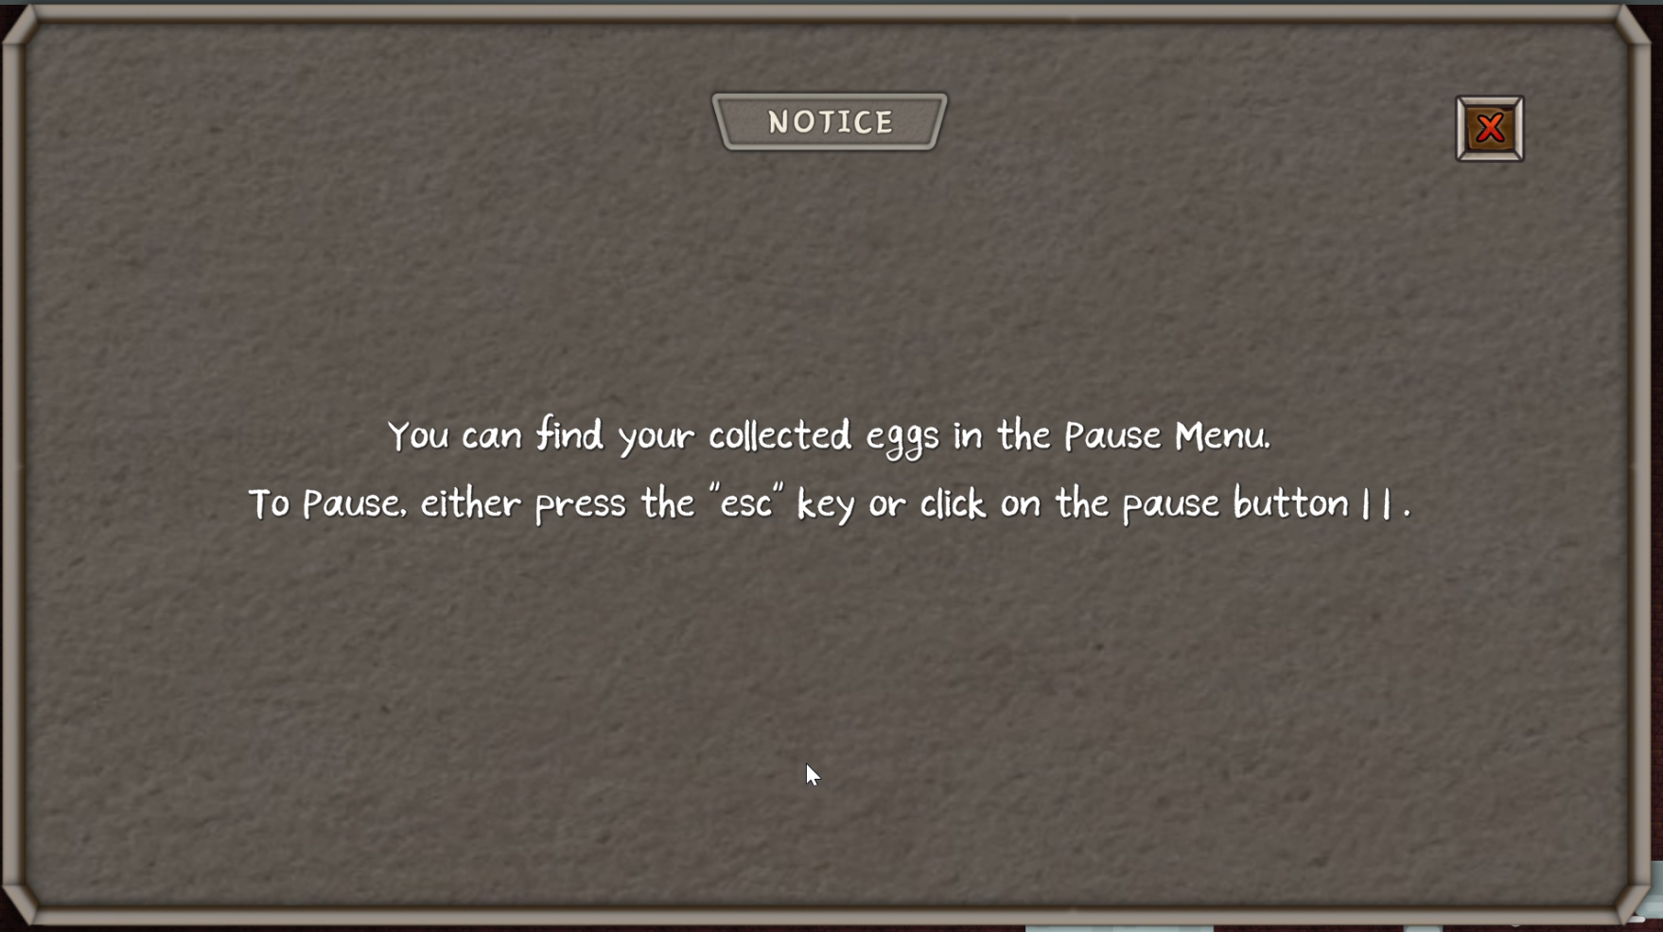

Fig 14. Tutorial Stage 4: Introduction of Egg Pickup

The Energy Core is also introduced at the last stage of the Tutorial Level where users have to traverse a great height with just the Shotgun by shooting repeatedly while recharging their gun with the energy cores in midair (Fig. 15).

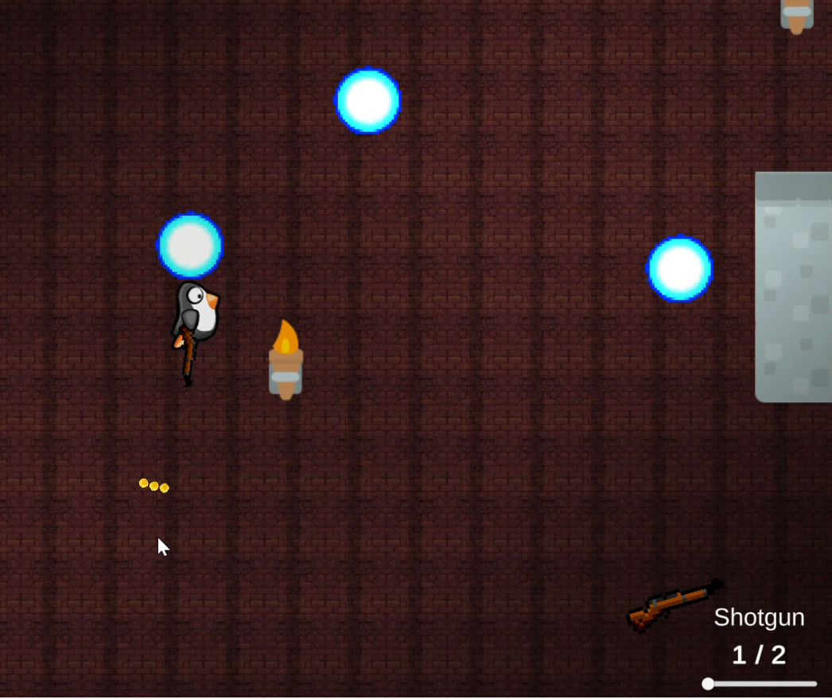

Fig 15. Tutorial Stage 5: Introduction of Energy Core

### Terrain

In addition to Enemies and Pickups, we also employed a combination of terrains in different stages.

|  |  |  |
| --- | --- | --- |
| **Name** | **Example Tiles** | **Description** |
| Normal ground |  | Pingu will walk normally and recoil is able to take place. Friction on this surface is also higher, enabling the player to control Pingu better.  In addition to the regular ground that Pingu usually walks on, there are also **moving platforms** in certain stages. |
| Icy ground |  | A **low friction** surface which will cause Pingu to slide. A sliding animation will be played when Pingu is on top of ice.  Players have less control over Pingu, and recoil is also reduced slightly, forcing them to tread carefully. |

Table 2. Terrains

## Player Mode

The player mode will be Single player. As a result, players do not need to choose a character. Instead, they will assume the role of Pingu. There is only one difficulty mode, in which players are able to respawn infinitely where stages are fixed.

## Game Rules

### Player

The player assumes one of the following states at any point of time as shown in Fig. 16, where the corresponding frames of animation are shown under each state, to assist users in controlling the character.

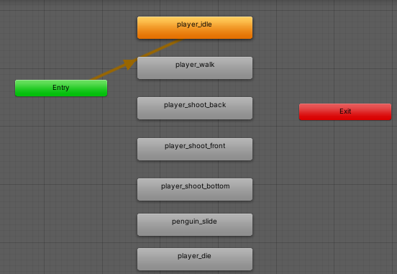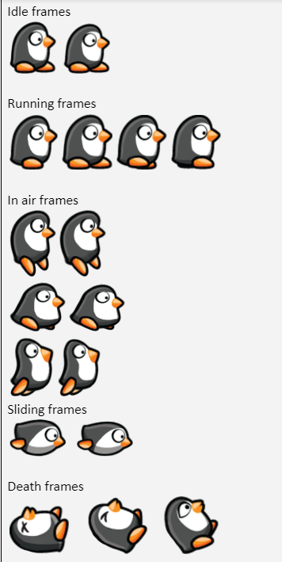

Fig 16. Animation State Machine and Animation Frames for specific states (left, right)

### Enemies

In addition to the Spikes that were illustrated previously, the following Table 3 also details the enemies that we have implemented and integrated into our Level Design and stages.

|  |  |
| --- | --- |
| **Type** | **Description of character** |
| Flying Enemy | * 1 hp * Can fly * Patrols in a predefined path * Cannot shoot * Can kill you if you touch it |
| Charger | * 1 hp * Patrols randomly along several waypoints * Chases after player if player is in line of sight and in range |
| Shooter | * 1 hp * Patrols randomly along several waypoints * Shoots at player if player is in range * Does not chase after player |
| Homing Mine | * Has a radius of activation * Follows player for 5 seconds then gets destroyed * Touching the homing mine will cause both the mine and player to be killed * Cannot be killed with guns |
| Trap based enemy | * Moves towards players if they are directly under it * Contact with the trap based enemy results in death * Cannot be killed |

Table 3. Enemies

### Screen Controls

Aside from the gameplay rules that were mentioned in the procedures for Movement, Weapon, Stage, Pickups and Terrains, players also have access to screen controls. At any point of time, users can exit to the main menu at the Pause Menu or quit the game and resume later on by clicking on the “Continue” button at the main menu (Fig. 17).

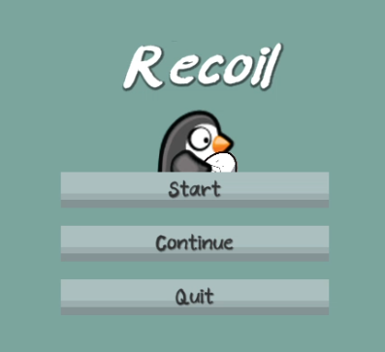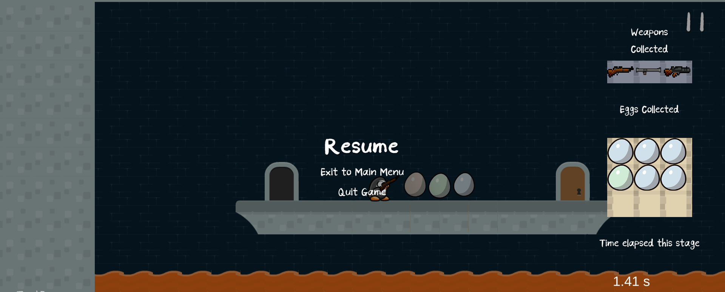

Fig 17. Main Menu and Pause Menu (Left, right)

## Resources

Each gun has an internal re-firing delay, which limits how often the recoil of the specific weapon can be used. Guns are reloaded only when a player touches the ground (and this is also why the ammo reload slider does not fill up while Pingu is in the air) or when they collect the Energy Core, and these are the only resource limitations imposed by the game upon the player.

## Conflict

Players are faced with several obstacles such as enemies where collision with them or their projectiles results in immediate death, platforms of which some are frozen and low friction providing some increased difficulty for players as well as platforms that sometimes create obstacles that can kill the players as well as crevasses and obstacles that can kill players if they fall into them or touch them. These must all be overcome to reach the end of the room and proceed to the next one.

Additionally, the specific arrangements of platforms require players to execute the recoil mechanic with some precision, such as platforms which are too high to reach without the use of a precisely-timed double shotgun recoil, or correct angling of a rocket launcher shot, or layouts that require players to dodge through narrow corridors. Players will be expected to make their way across various platforming challenges, which include, but are not limited to:

1. Timing a double jump in air to change direction of travel
2. Timing the use of the rocket launcher’s projectile explosion to gain height or excess speed, and changing weapons when necessary
3. Execution challenges involving timing jumps and shots to avoid contact with enemies on platforms

### Level Design

Each level will either test the player's ability to execute specific maneuvers with varying combinations of weapons, or have sections that are designed to teach them new maneuvers. As mentioned in the Pickups and Terrains section, there will be some stages which require players to leverage both to progress in the stage.

An example is shown below where players are expected to utilize the low-friction icy surface to gain excess speed to move further distances (Fig 18). Without sufficient momentum built up by sliding down the ice slope in the middle, the players will fail to jump over the spikes. The platforms in the middle of the stage provide a way for players to get back up to the top to slide down again in case they missed their slide. In case they tried shooting in the middle of a slide, which would cancel the momentum that was built up by the ice slope, while they might be able to fly past the spikes, they might not land far enough to reach for the Egg. We have designed the ice slopes in a way that players are not able to slide back up. For collectors or completionists, they may choose to intentionally respawn to get the Egg, and for Killer archetype players, they could simply ignore the Egg and proceed to the next level, while still experiencing the satisfaction of the sliding mechanic.

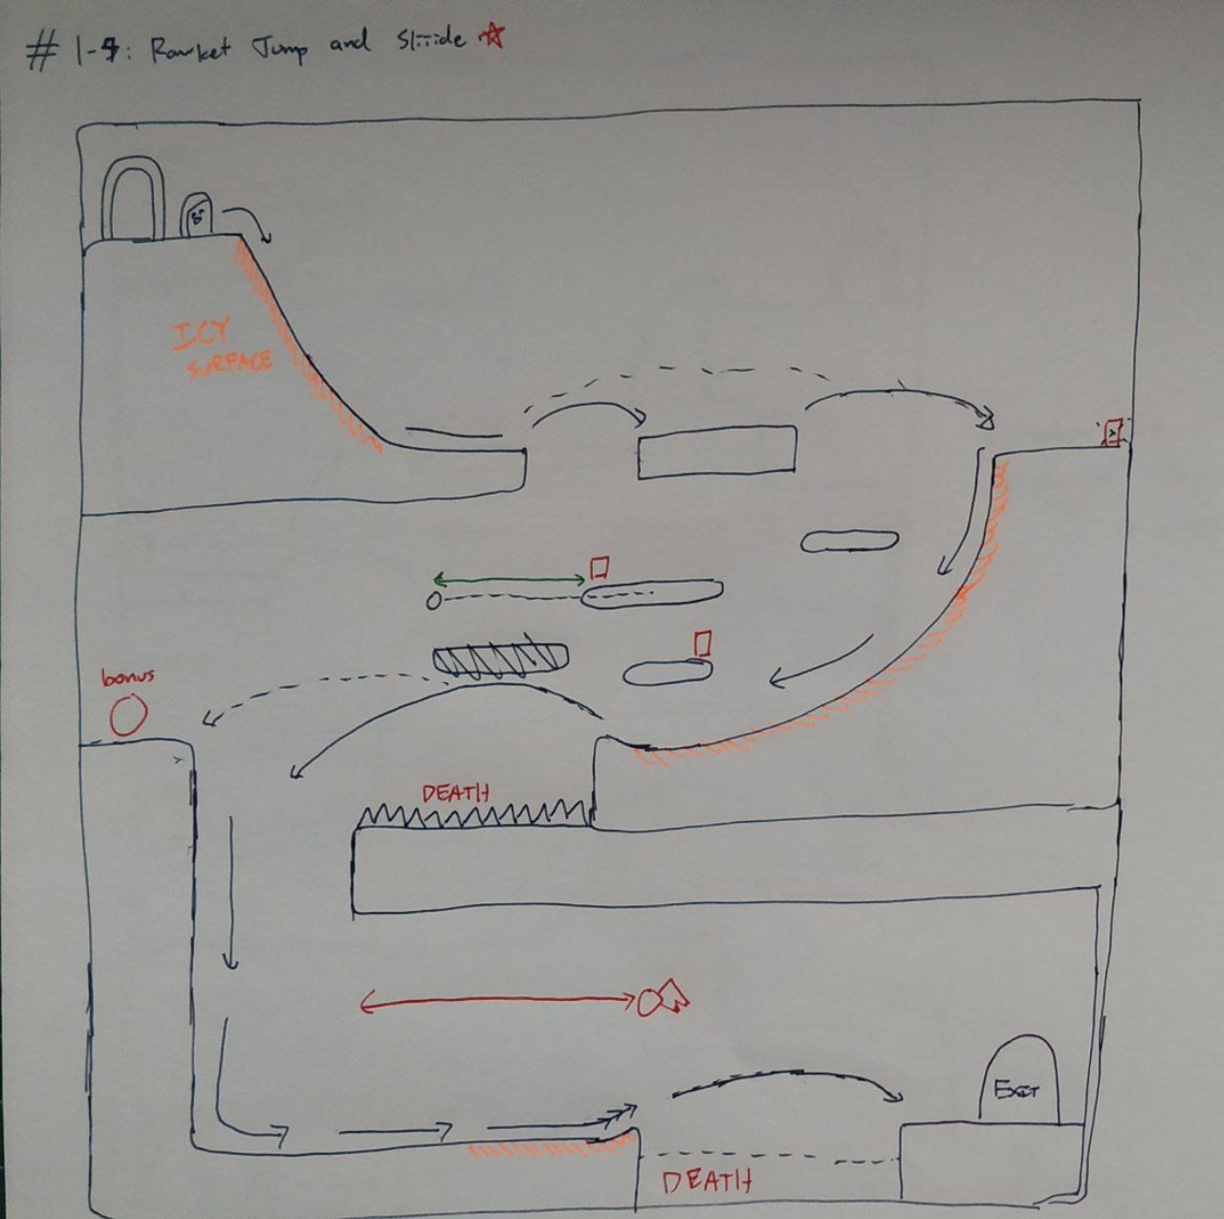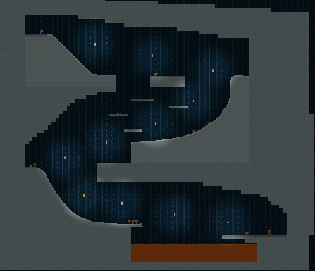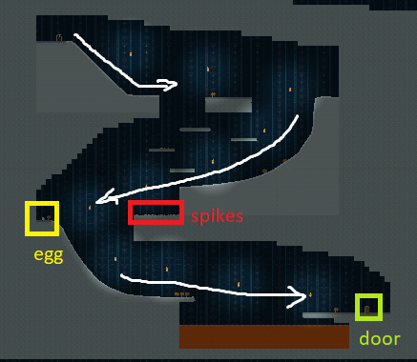

Fig 18. Concept sketch, actual game and labelled images of Stage 2-4 which focus on ice terrains (from left to right)

Other stages are also designed intricately with specific objectives for the players to achieve and improve their mastery over the recoil mechanics. We also attached a table in Appendix B to show the sketches for other stages in our game after the first 5 tutorial stages and the objectives for each of those stages.

For the boss stage, we have designed it in a way that tests the player’s mastery over the 3 different weapon recoil mechanics and also the players’ ability to platform while under pressure. Prior to entering the actual Navy Seal’s room, the last stage tests the player’s preciseness in controlling the recoil mechanic as the entire room is filled with only icy terrains and spikes. After which, they will enter the Navy Seal’s room where the boss battle introduces one new mechanic comprised of other mechanics:

* The Navy Seal will shoot projectiles like Shooter enemies, except that the projectiles are shot in a circular arc. The Navy Seal will shoot if the player is close enough, and does not need to sight the player. When the Navy Seal shoots projectiles, its angry animation will be played.
* Batteries are the shield gauge of the Navy Seal’s barrier - when they are all destroyed, the final resolution and sequence begins where the Navy Seal shoots projectiles that explicitly target the player.
* Platforming up to the Navy Seal, the batteries, and then shooting them, while avoiding or destroying other smaller enemies.

The Navy Seal’s room boss stage can be seen in Fig. 19.

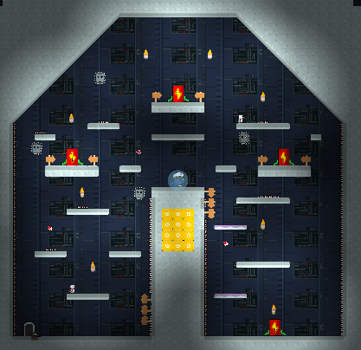

Fig 19. Boss Stage

### Game Balance & Asymmetry

While each weapon provides a unique mode of movement, there are some that are much better at allowing users to control their movement than others which will inevitably cause users to gravitate towards those weapons creating a degenerate strategy. To combat this, each weapon will have to be recharged after use to prevent previously acquired weapons from becoming obsolete. This also adds an aspect of resource management to the game which requires users to make decisions on which weapons are to be used in which situation even though multiple available weapons are able to achieve the same objective as they may need to be used for other objectives.

## Boundaries

Players should not be able to get out of the map. The map will be bound in a box, an example can be seen in Fig. 18’s actual game image and Fig. 19. The playspace is otherwise free for players to roam as they wish.

## Outcome

When players finally defeat the Navy Seal, they are rewarded with a short cutscene and an animation playing out with explosions as he is defeated (Fig. 20). This is followed by an end-scene, where players will see Pingu the Penguin be reunited with Benedict the Egg, and a bonus scene where all of the collected bonuses of the player will all turn into little penguins and a tally will be shown. An example of one of our Playtester’s game results are shown in Fig. 21, where the player has collected all the eggs (3 green, 3 blue, 3 red, and Benedict). They are also shown the total time they took to play the game and the number of times they have respawned throughout the game. This playtester has participated in 2 of the Beta Testings that were conducted (Beta Testing 1 and 3).



Fig 20. Collage: Navy Seal Dying, Benedict Hatching

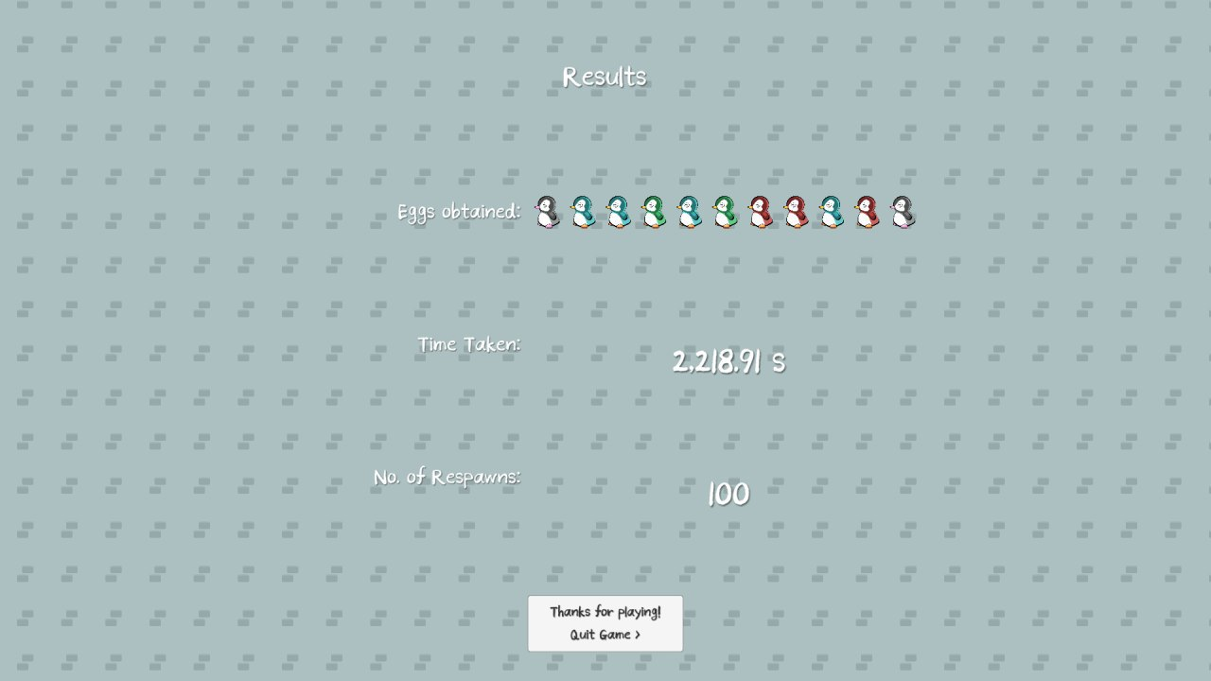

Fig 21. Game Results from playtester

# User Testing

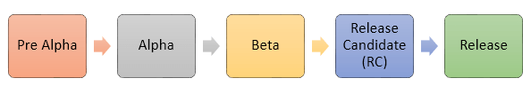

Fig 22. Phases of Testing

Following the [Phases of Testing](https://www.guru99.com/alpha-beta-testing-demystified.html#:~:text=Alpha%20testing%20is%20a%20type,everyday%20users%20or%20the%20public.&text=Alpha%20testing%20is%20carried%20out,internal%20employees%20of%20the%20organization.) in Fig. 22, we have performed Alpha and Beta Testing.

## Alpha Testing

Internal acceptance testing was performed periodically throughout the development of the game. The developers and the level designers communicated frequently to confirm on the best way to deliver features that enhance gameplay experience and to discover bugs that had to be fixed before conducting Beta Testing with the general public. We had redesigned many stages iteratively after receiving feedback from both the level designers, game developers as well as our playtesters from the Beta Testings.

## Beta Testing Round 1 (Pre-checkpoint 3)

### Methodology

The first user testing session for the alpha version of the game was conducted between 3rd and 4th of August 2020. During this round of playtesting, only the first 2 levels were released (tutorial stage up to stage 2-5). The tests were mostly conducted remotely by sending out a Microsoft Forms link with the game download link available to interested players. This playtest session is conducted entirely without a facilitator.

### Objective

The objective of this playtest is to see whether the different Recoil mechanics that we have developed with the Shotgun and the Rocket are fun to play with, and how we can improve them. We also hope that the playtesters can help us discover edge cases that the internal testing did not find. We also want to know if the stages that were designed fits an appropriate learning curve of the general public.

### Results

The summary results of Beta Testing 1 can be found [here](https://forms.office.com/Pages/AnalysisPage.aspx?id=drd2NJDpck-5UGJImDFiPYfe-PAi9gxIgpLB6ZwE8llURFNINVNMMkczRERXWEtPM0lPTzMxNzczNS4u&AnalyzerToken=D9HMYXxi5vhJXFUXJEbz9QVI3O9s9Wfm), consisting of responses from 8 players.

Feedback that were important in improving our game fell into the following categories:

* **Technical Bugs:** Player getting stuck in platforms if landed on edges. Continuing the game from Main Menu does not load eggs collected correctly at the Results.
* **Frustration with certain game levels:** Players dying to spikes accidentally, despite not in very close proximity
* **Confusion on mechanics:** Players were somewhat confused about how the rocket projectile causes recoil.
* **UI improvements:** Lack of a quit button at the results screen, Hints for stages are not explanatory enough.

Due to technical difficulties that they have faced in the feedback, around half of the users did not complete all of the levels, which is a surprising result, as most of these technical difficulties were thought to be rather easy to get around with. It shows the importance of having reliable mechanics where Pingu is able to maneuver more precisely to the players’ expectations.

Nonetheless, the players generally found the premise and the mechanics employed in the game to be genuinely promising, giving Recoil an average rating of 4.00 on a Likert scale.

## Beta Testing Round 2 (Pre-checkpoint 3)

### How the game is improved

We took action on the feedback given from our first round of playtesting and implemented fixes such as:

* **Hitboxes:** Reducing the hitbox of the player and spikes to make the game more forgiving
* **Controls:** Tweaking the controls of the player to make it less twitchy (hence lower likelihood of accidentally touching spikes)
* **UI:** Adding a quit button at game results screen

### Methodology

In the middle of these developments, we produced another beta build that contained fixes for a number of frustrations found in Beta Testing 1. Similarly, only the first 2 levels are available. For this playtest, we tested it with a separate and smaller pool of 3 players on this beta build but with minor facilitation, where users can ask questions immediately when they face a technical difficulty. We performed data collection in person instead of using the online forms as the groups of players were small, and these players were also given an equivalent form to fill.

### Results

The minor facilitation has yielded us more precise feedback to improve our game.

* **Rocket Mechanics:** Rocket Launcher projectiles were not correctly interacting with the colliders
* **Level Design:** Certain levels had extraneous level elements that were confusing, such as misleading signposts or lack of signposts.
* **Moment-to-moment feedback can be better:** Events such as obtaining pickups like weapons and eggs, and respawning can be more meaningful. Not intuitive to know that the weapon is reloading while on ground.
* **Extra Features Requested, but not mandatory for experience:** More checkpoints would be useful on longer levels

Players from this group were also generally happy with the variety in level designs, and the incremental pacing of the mechanics required of players.

## Beta Testing Round 3 (Pre-checkpoint 4)

### Methodology and Final Improvements

In the latest user testing that we have conducted on 10th and 11th August, the full game is ready, with 21 stages available from the 4 Levels including Tutorial, and the Boss Stage. After completing the boss stage, players will see an end cutscene that was detailed in the collage (Fig. 18). The third weapon, the Flamethrower is also available in this build.

We have also made significant improvements to the following from the build in Beta Testing Round 2:

* **Major Improvements for Moment-to-moment feedback in different aspects of the game** 
  + **Weapon Mechanics:** Weapon UI Ammo Reload Cooldown Slider and adjusting recoil parameters for the Flamethrower, Shotgun and Rocket to ‘feel better’.
  + **Weapon Pickups:** Weapon Pickup with Shiny Effect confirmation UIand also their respective hint to introduce what they can be used for, and how to switch to different weapons.
  + **Egg Pickups:** Produce an audio cue of baby penguin chirping when the player is nearby and show a visual vibrate effect. Picking up individual eggs also shows a UI telling users different lore of the Navy Seal’s labyrinth, some of which helps them anticipate the mechanics of upcoming stages, while some also tell the user how far they have proceeded in the game and how close they are to reaching the Navy Seal. This is meant to address moment-to-moment feedback for Egg Pickups.
  + Added **Hint Pickups** for more difficult stages
  + **Inventory** and time elapsed for current stage at Pause Menu
  + **Game Results** properly aligned and show eggs collected hatching into penguins, respawn counter, total time elapsed.
* **Level Design**: Adjustments across the board to improve the difficulty curve for players, expansion of several levels to ensure that player frustration would be lessened when they attempted the levels. Many spike placements were adjusted, and icy surfaces were also carefully adjusted to feel less punishing to players.
* **Save and Load System:** The save files now preserve the pickups that they have obtained and the time that they have spent in that stage. Upon loading the save file, previously taken items such as the Egg and Weapon Crate will not spawn in the scene again, while time elapsed continues from what is recorded.
* **Main Menu**: Added Pingu & Benedict near the Start button. Pingu can be clicked at his butt and at the egg to show a cute and pained expression. Loading works correctly.

We conducted the tests similarly as Beta Testing Round 1, where players play the game unsupervised with no other specific instructions., aside from having the download link to the game and having to answer the survey themselves.

### Objective

With the game in a complete state, this round of testing was there to figure out if there were any bugs that would be potentially game breaking or degenerate. We were looking for minor adjustments and general feel of the game, as well as to see if there were any specific features that they would be looking for, for future expansions to *Recoil*.

### Results

* While we have managed to perform Speed Runs in our internal testing team, taking an average of 12mins to complete the game, for the players that we have gathered for the third Beta Testing that completed the game, some of which including previous playtesters, took an average of 35 minutes, this is about thrice as long as the internal testing team.
  + This also reiterates the absolute importance of conducting playtesting with users outside of the internal testing group
  + And although 35 minutes is relatively long, the majority of the players felt the duration is just right for one playthrough.
* For the players that did not complete the game, they still took an average of 20mins to try out the game. This is a rather pleasant surprise, as this does indicate a real engagement and connection of our game with the players.
* The main reasons for not completing the game were also raised as pain points by the ones who completed the game, and these include:
  + Lack of checkpoint locations within a single level
  + Overall level challenge getting slightly too frustrating to pass
  + Physics engine problems which were difficult to resolve for the developers

The summary results can be found [here](https://forms.office.com/Pages/AnalysisPage.aspx?id=drd2NJDpck-5UGJImDFiPYfe-PAi9gxIgpLB6ZwE8llUN0MxS0JaNTBXUU0yU01HV01YRDVZWUpNNi4u&AnalyzerToken=D9HMYXxi5vhJXFUXJEbz9QVI3O9s9Wfm).

A full playthrough may be found at this link: <https://youtu.be/2_mM3nSqtXs>

# Future Improvements

After our final playtest, users still occasionally face some bugs. For instance, players sometimes get stuck in between platforms and face inconsistencies in recoil of certain weapons, causing some level of frustration. Fixing these bugs will definitely result in a better gameplay experience, however we were not able to do so due to time constraints and lack of expertise in the physics engine. After fixing these bugs, we could conduct a Release Candidate Testing session with a larger pool of players with the Leaderboard feature implemented for comparing Speed Runs.

For future expansion of the game’s content, perhaps larger maps, with checkpoints implemented of course, and more weapons with unique mechanics could be introduced. The full scale implementation of the game might possibly include several worlds, each with a unique mission and boss battle. The story for the expansion may cover what happens to Pingu after he saves Benedict and the other baby penguins - and why the other penguins look so different compared to Benedict and Pingu (the story is a sci-fi plot anyway). Additionally, a multiplayer version of the game could be explored, allowing online play to overcome cooperative platforming challenges, assuming different penguin characters (or maybe even the seal?).

# Assets

Some of the assets that were chosen for our characters were self-created while the others were found online for free (Fig. 21). The custom sprites include the Homing Mine, Trap Enemy and Navy Seal, and the rest are found online.

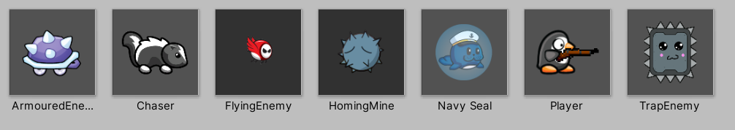

Fig 21. Character Sprites

To allow players to feel more immersed in the recoil mechanic when playing as Pingu, we have intentionally cropped out specific body parts from the original sprite sheet and distorted them accordingly to show Pingu being pushed by recoil in the respective directions (Fig. 16, 22). As a result, in playtesting, players have shown great appreciation for how alive the penguin feels in-game and enjoyed the game better.

|  |
| --- |
| → |

Fig 22. Original Sprite Sheet (left), Cropping out specific body parts for manipulation(right)

For a more comprehensive view of all the sprites used for the game, please refer to Appendix A.

# GDD Changes since Midterm

We have delivered what we have proposed.

# Schedule

|  |  |
| --- | --- |
| **Time period** | **Features to be worked on** |
| Initial Experiments  (Week 2 to 4) | * Develop a simple project based on a player controller with placeholder sprites * Develop a weapon controller which points a weapon in the direction of the mouse with respect to the player |
| Creating the base project (Weeks 4 to 8) | * Base application with working player controller and weapon controller   + Using placeholder sprites * Setup github repository * Implement Tutorial Level Stages (x5 stages) * Implement Level 1 Stages (x5 stages) |
| Checkpoint 1  (Week 8) | 1. Coding    1. Additional weapons    2. Ammo display UI    3. Weapon mechanics e.g. firing delay    4. Basic enemy class (+ subclasses for different enemies)    5. Singleton Manager for respawning all enemies and player       1. (this and object pooler should persists across scenes) 2. Assets    1. Enemy    2. Background    3. Gun bullet and particle effects    4. BGM and SFX 3. Level Design    1. Tutorial       1. A-D horizontal movement       2. Picking up the gun and vertical jumps (one way platforms + double jumps)       3. Horizontal Jumps       4. “Mini obstacle course” with obstacles and stationary enemy and ice? (sleeping dude guarding entrance to inside of the facility)    2. Planning for later stages and boss fight    3. Confirm all types of pickups, platforms, enemies |
| Checkpoint 2  (Week 10) | 1. Coding    1. Internal testing       1. Tweaking of parameters such as gravity, recoil mechanics for better game play       2. Animations       3. Cinemachine parameters for UX    2. Pickups [done]    3. Platforms that can be jumped upon from below [done]    4. How enemy interacts with projectiles [done]    5. How player interacts with enemy projectiles and enemies [done]    6. Flamethrower    7. Scoring system       1. Number of deaths       2. Time taken to complete stage       3. Number of eggs    8. Main menu    9. Game settings and pause menu 2. Levels    1. Stage 1 and 2    2. Time Pressure Final Stage + Teleporting Boss? |
| Checkpoint 3  (Week 11) | 1. External testing: Playtesting - getting feedback to show that how our players like it, how else they would want in the game, what they don’t like about it 2. Quality Assurance: Fixing bugs identified by players |
| Checkpoint 4  (Week 13) | All of the promised features done! |

# 

# Appendix

## Appendix A - Assets

### Main Characters

|  |  |  |
| --- | --- | --- |
| **Character** | **Sprites** | **Description of character** |
| Pingu | Idle frames    Running frames    In air frames        Sliding frames    Death frames    Penguin arm    Source: <https://www.gameartguppy.com/shop/penguin/>  Note: All sprites were photoshopped to remove arms and/or scaled down slightly in the y axis to create a second frame in the animation. In air frames were created by using “puppet transform” in photoshop on the standard frames. **This is done by Dominic.** | Narrative   * He can’t jump or fly, but he can definitely cry.   Skills, stats and special abilities   * 1 hp * Carries 3 weapons   + Shotgun   + Rocket Launcher   + Flame thrower * Walks left and right * Has air control when bullet jumping |
| Benedict | Source: **self made by Siew Wen** | Narrative:   * Your unborn baby cousin named benedict, still in an eggshell |
| Navy Seal | Seal_idle:    Seal_angry:    Seal_move:    Seal_laugh:    Seal_salute:    Source: **self made by Nath & Gui An**  Boss projectile    Source: <https://kvsr.itch.io/fireball-animation?download>  Battery    Source: **self made by Dominic**  Shield:    Source: **self made by Dominic** | Narrative:   * Some say he is a seal, others say he is a pretender.   Skills, stats  Boss skills stats   * Shield protects Navy Seal when batteries in boss stage are present * Shoots a radius of projectiles when shields are up * Shoots projectiles towards the player’s direction when shields are down   Boss Stage   * *batteries included* |

### Enemies

|  |  |  |
| --- | --- | --- |
| **Type** | **Sprites and Assets** | **Description of character** |
| Flying Enemy | Idle/run:      Source: <https://dribbble.com/shots/1610469-Animation-Flappy-Rider-Enemy-Game-Character> | * 1 hp * Can fly * Patrols in a predefined path * Cannot shoot * Can kill you if you touch it |
| Charger | Idle    Run    Source: <https://www.gameartguppy.com/shop/mini-monster-6-skunk/> | * 1 hp * Patrols randomly along several waypoints * Chases after player if player is in line of sight and in range |
| Shooter | Idle/run    Attack:    Source: <https://graphicriver.net/item/snowman-character-sprite/12717854> | * 1 hp * Patrols randomly along several waypoints * Shoots at player if player is in range * Does not chase after player |
| Homing Mine | Attack    Idle      Source: **self made by Nath** | * Has a radius of activation * Follows player for 5 seconds then gets destroyed * Touching the homing mine will cause both the mine and player to be killed * Cannot be killed with guns |
| Armoured Enemy | Idle/Run    Source: <https://www.gameartguppy.com/shop/robot-turtle/> | * 1 hp * Can only be killed with rocket launcher (other weapon types are ineffective) * Moves slower than other enemy types |
| Trap based enemy | Idle    Attack    Source: **self made by Nath** | * Moves towards players if they are directly under it * Contact with the trap based enemy results in death * Cannot be killed |

Common enemy characteristics:

* All enemy units can be killed with any weapon type unless stated otherwise

### Player Weapons

|  |  |  |
| --- | --- | --- |
| **Weapon** | **Sprites and assets** | **Skills, stats, special abilities** |
| Shotgun | Weapon Sprite    Source: <https://bigmack.itch.io/wwii-mega-gun-pack>  Projectile    Source: **self made by Dominic** | The Shotgun comes with 2 shots. It is the first gun that the player uses and fires 3 projectiles in a cone shaped pattern from the muzzle of the gun. |
| Rocket | Weapon Sprite    Source: **self made by Siew Wen + Gui An**  Projectile    Source: <https://www.goldhawkinteractive.com/forums/uploads/monthly_2017_02/40mm.q80.jpg.ddf1d6f34acadd8b07a61a71f745e62d.jpg> | The Rocket Launcher comes with 1 shot. It fires a slow moving projectile that creates a recoil when it collides with a platform/enemy. This projectile can be used to create recoil that is originally inaccessible to players where they need it, requiring them to plan and fire the launcher ahead of time. |
| Flamethrower | Weapon Sprite    Source: <https://bigmack.itch.io/wwii-mega-gun-pack>  Projectile:  Unity in-built particle effect | The Flamethrower comes with 10 shots. It serves to aid players in air control while being in the air, giving them the maneuverability in air to complete specific stages. |

### Pickups

|  |  |  |  |
| --- | --- | --- | --- |
| **Pickup** | **Sprite** | **Sound** | **Effect** |
| Hint | Source: <https://www.seekpng.com/ima/u2q8a9o0r5i1t4e6/> | Sharp, clean sound | Shows Hint UI |
| Easter egg | Source: **Self-made by Siew Wen** | Egg pickup:  <https://jdwasabi.itch.io/8-bit-16-bit-sound-effects-pack>  Baby Penguin call:  <https://audiojungle.net/item/baby-penguin-calls/11454851> | Easter egg  Will hatch into penguin later at ending if you rescue them |
| Weapon Crate | Source: same as Tiles later | NIL | Player gets a new weapon at their disposal. Able to switch weapons if the player has more than one. |
| Energy Core | Source: <https://lvgames.itch.io/free-glowing-ball-sprite-pixel-fx-rpg-maker-ready> | Sharp, clean sound | Refill Ammo |

### Background

|  |  |  |  |
| --- | --- | --- | --- |
| **Level** | **Music** | **Background sprite** | **Tiles** |
| Story Cutscene | [Help! - Pokémon Ruby/Sapphire/Emerald](https://www.youtube.com/watch?v=y2EHd4qAm-w)  [Overworld Theme - Super Mario: World](https://www.youtube.com/watch?v=tAaGKo4XVvM) |  |  |
| Tutorial | Hitman (Kevin McLeod) Vanoss Gaming Background Music (HD) | Base:  <https://szadiart.itch.io/pixle-castle-2d> |
| Level 1 | Remix of:  [Air of Unease - Pokémon Mystery Dungeon: Explorers of Sky](https://www.youtube.com/watch?v=xz7c1u4nraM)  By Nath | Base: <https://bghq.com/bgs/snes/m/mmx/084.png> |
| Level 2 | Remix of:  [Pokemon- Mystery Dungeon Explorers of Sky- Blizzard Island Rescue Team- Music](https://www.youtube.com/watch?v=OYb5A1Yvhro)  By Nath | Base: <https://bghq.com/bgs/snes/m/mmx/075.png> |
| Level 3 | Remix of:  [Lava Overworld - New Super Mario Bros.](https://www.youtube.com/watch?v=E9hxJwInyck)  By Nath | Base: <https://bghq.com/bgs/psx/m/mmx5/064.png> |
| Boss Fight | Remix of:  [Magma Flows - Kirby Air Ride](https://www.youtube.com/watch?v=G8TggmkHNvs)  By Nath |

## 

## Appendix B - Level Design Sketches

|  |  |  |
| --- | --- | --- |
| **Stage** | **Sketch** | **Objectives and Mechanics** |
| Stage 1-1 |  | Idea: Introduce enemies into the play field, generate sense of threat  “Gloves off” for basic jumping mechanics - players are expected to either learn to figure out how to make the jump, or *die trying* |
| Stage 1-2 |  | Introduce moving platforms  Introduce flying enemies  Introduce the idea of crossing larger gaps by utilizing multiple platforms  “Moving platforms may or may not be your friend” |
| Stage 1-3 |  | A simple stage to test the player’s control over the shotgun. Should be moderately easy to complete. Also should teach players how to control their jump distance as jumps that are too long will be punished by the ice platform. |
| Stage 1-4 |  | Idea: Introduce a choice for the player to make between choosing a safer, slower route or a faster and more dangerous route that requires much more precision to complete. Also introduce platforms that are fully solid to teach players how to jump onto vertical platforms without simply shooting downwards  **After Internal Testing:** It is also an avenue to introduce the homing mine, maybe just before the level ends |
| Stage 1-5 |  | Idea: Stage should test player’s skill in making continuous jumps while midair. Players must demonstrate a good level of mastery of the shotgun and its recoil mechanics in order to pass the stage.  **After Internal Testing**: Homing mines are added for elevated difficulty from TutorialStage1-5. |
| Stage 2-1 |  | Introduce ‘trap’ enemies that slam down when you go past them  Allow players to practice jumping mechanics safely around trap enemies  Teach players about doubling back  Further practice for horizontal movement and jumping |
| Stage 2-2 |  | Introduce the idea of the mid-air double jump  Allow players to practice avoiding and jumping mechanics  Practice of mid-air timed jumps as means of clearing low ceilings |
| Stage 2-3 |  | Addition of Armored Enemies:  Enemies that don’t die to shotguns, only rocket launchers  Have safe space to play with rocket launcher recoil  Introduce the idea of higher jumps requiring the rocket launcher |
| Stage 2-4 |  | Introduce the icy slope as a means of gaining additional momentum for a jump  “Long jump” mechanics dependent on icy floors, offer a safe-ish space to experiment if the player gets cold feet |
| Stage 2-5 |  | “Capstone” level for Stage 2:  Give players the chance to learn “mid-air” jumps with rocket launcher/shotgun, bring together mechanics learned over the course of stage 2 and stage 1. Players who have mastered the mechanics of both rocket launcher and shotgun should be able to clear this level with relative ease.  Trap enemy: needs to be introduced in stage 2 earlier |
| Boss Fight |  | 2 rooms:  First a climb towards the ‘fight room’ - tests of player competence - allow players the chance to demonstrate their skills  Bossfight:  Introduction of one single new mechanic comprised of other mechanics:  Platforming up to the enemy, and then shooting it  Batteries are the ‘lifebars’ of the Navy Seal - when they are all destroyed, the final resolution and sequence begins.  The boss fight also tests players’ ability to platform while under pressure, since the boss will rotate between firing at the player and in directions. |
| 3-1 |  | Provide space for player to play around with flamethrower, overhang should block rocket jump and require vertical flamethrower control from player |
| 3-2 |  | THE LADDER V2, throwback to ladder level, show what flamethrower can achieve with regards to precision |
| 3-3 |  | Testing player’s ability to swap between weapons and combine them together |
| 3-4 |  | Testing combination of mechanics, particularly air control and timing |
| 3-5 |  | Testing combination of mechanics, requires more mastery than 3-4 |